Personal Care Products Needed

YOU can make a difference in seniors and children’s lives by donating these essentials.

A Complete Personal Care Kit includes the following items.

- 1 Shampoo
- 1 Conditioner
- 1 Liquid Hand Soap
- 2 Toothbrushes
- 2 Toothpastes
- 2 Bars of Soap or Body Wash (1 body wash=2 soap bars)

Can also include: Mouthwash, Deodorant, Lotion

After assembling the care kit, please drop it off at HSP to be distributed to seniors and children in need!

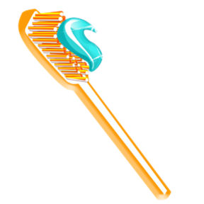
Humanitarian Service Project
465 Randy Rd, Carol Stream, IL 60188
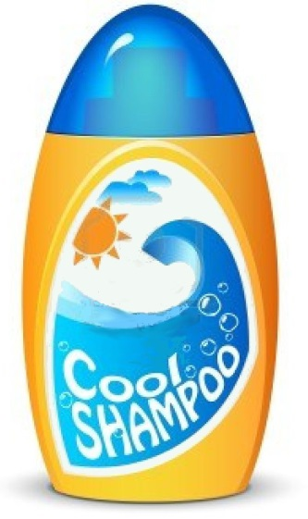
Phone: (630) 221-8340
Email: HSP@hsp.agency

www.hsp.agency

